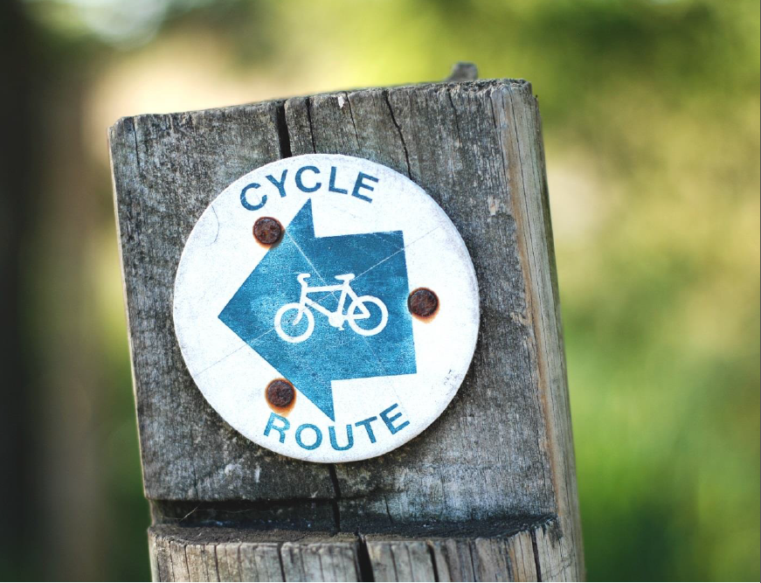

World Car Free Day – 22 September
Give your car a day off! Riding a bike or walking is sustainable and creates zero emissions. Enjoy the fresh breeze and breathe the clean air!
As a Green Key awarded, environmentally conscious establishment, we are happy to assist you in getting a bike and to find your way around.

