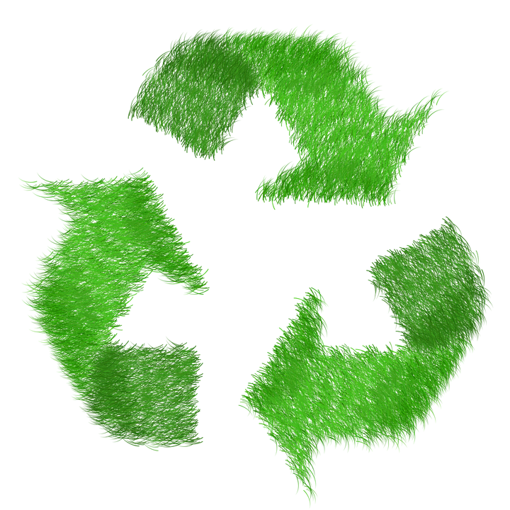

European Week for Waste Reduction – Dates XX
The European Week for Waste Reduction is a campaign for resource efficiency, circular economy and minimal consumption. As a Green Key certified establishment, we want to reduce waste every week of the year, and we do it by minimizing, recycling and reusing waste.

